Countermovement Jump and Squat Jump Force-Time Analysis Application
Methodology
Version 1.0 | October 2026
By Kyle Sands and Dr. Jacob Goodin

1. Purpose and Scope
This document records the Version 1 methodology implemented in the force-time analysis application. The application accepts raw ForceDecks CSV exports, sums bilateral vertical ground reaction force, performs explicitly documented signal processing, identifies CMJ and SJ events/phases, calculates force-time metrics, visualizes the analyzed trial, and exports results. The goal is transparency and reproducibility rather than replication of proprietary VALD ForceDecks or Hawkin Dynamics algorithms.
- Tests: countermovement jump (CMJ) and squat jump (SJ).
- Primary signal: summed bilateral vertical ground-reaction force (Fz).
- Outputs: jump height, takeoff velocity, force, power, impulse, phase durations, RFD/loading-rate metrics, landing metrics, annotated plots, and exportable results.

2. Guiding Methodological Principle
Force platform metrics depend on processing choices. Sampling frequency, filtering, weighing, integration, event thresholds, and metric windows can materially affect the reported value. The application therefore stores and reports the processing settings used and defines biomechanical events before calculating phase specific metrics.
Commercial system outputs are treated as useful external comparisons, not targets to reverse engineer. A method is retained when it is biomechanically defensible and behaves consistently across validation trials.

3. Input Signal and Preprocessing

3.1 Total vertical ground-reaction force
For bilateral ForceDecks exports, total vertical ground-reaction force is obtained by summing the left and right vertical-force signals. All other quantities are calculated from the force signal.
Total Vertical Ground-Reaction Force
$F_{z}\left(t\right)=F_{z,L}\left(t\right)+F_{z,R}\left(t\right)$ (1)

3.2 Sampling frequency
Sampling frequency is estimated from the median interval between consecutive timestamps. Development and validation files used 1000 Hz data.

3.3 Two-signal filtering architecture
The Version 0.6 implementation uses separate signals for movement mechanics and landing impact analysis. Both filters are fourth-order, zero-phase Butterworth low-pass filters implemented with forward backward filtering.
Table 1.
Signal | Cutoff | Application
Raw Fz | None | CMJ provisional flight detection, final takeoff detection, and landing contact detection
Movement-mechanics Fz | 15 Hz | Body weight, net force, acceleration, velocity, displacement, power, CMJ/SJ phases, force/impulse metrics, braking and propulsive RFD
Landing-impact Fz | 85 Hz | Peak landing force and peak landing loading rate
The 15Hz movement cutoff was selected after a 10/15/20Hz sensitivity comparison. Core outcomes such as takeoff velocity and jump height were nearly unchanged, while 10Hz visibly skewed transitions between phases and 20Hz retained too much variability (noise) in the signal. Fifteen Hz was used as a practical compromise for Version 0.6.

Figure 1. Takeoff region sensitivity comparison for raw, 10Hz, 15Hz, 20Hz, and 85Hz force signals.
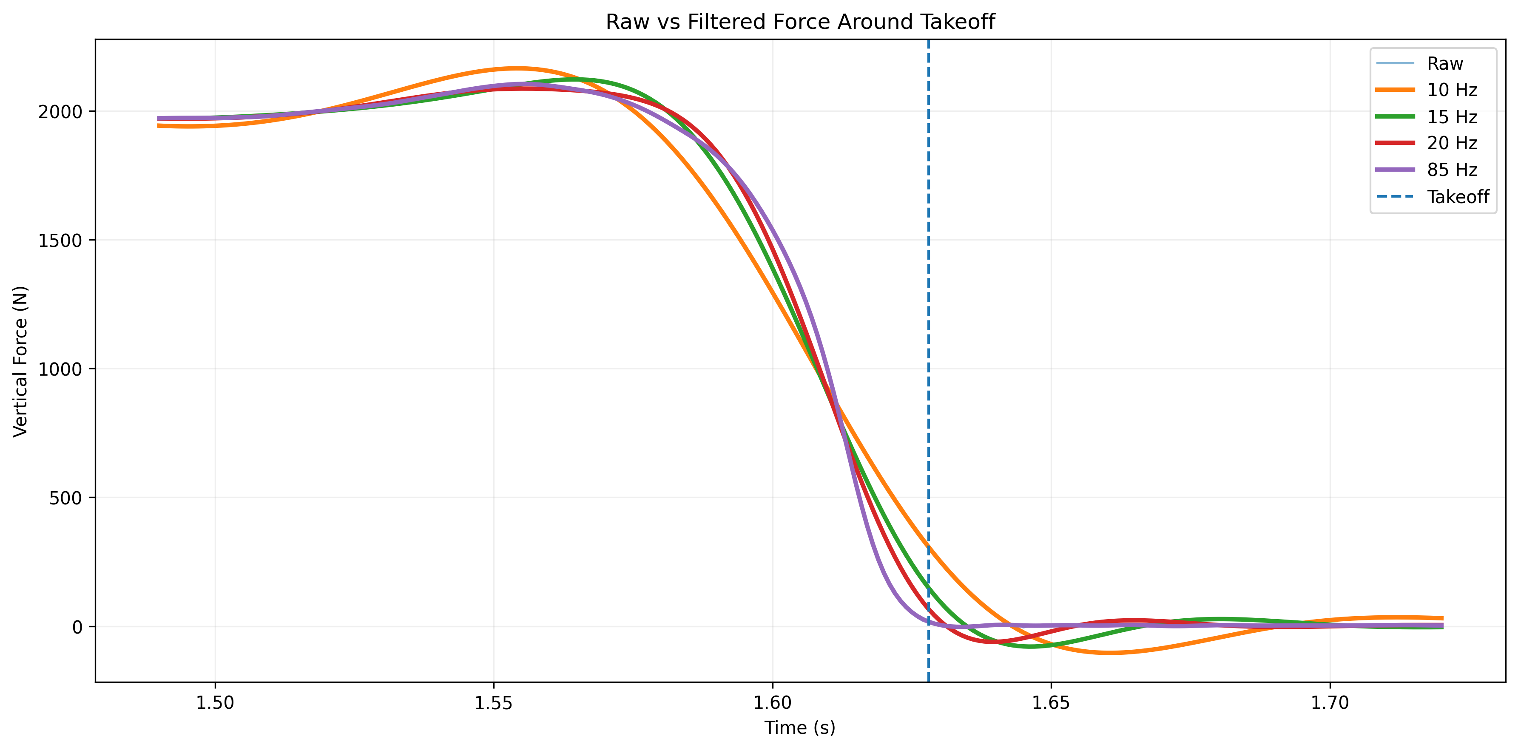
Figure 2. Landing region sensitivity comparison for raw, 10Hz, 15Hz, 20Hz, and 85Hz. Filtering has a large effect on force trace at and around landing.
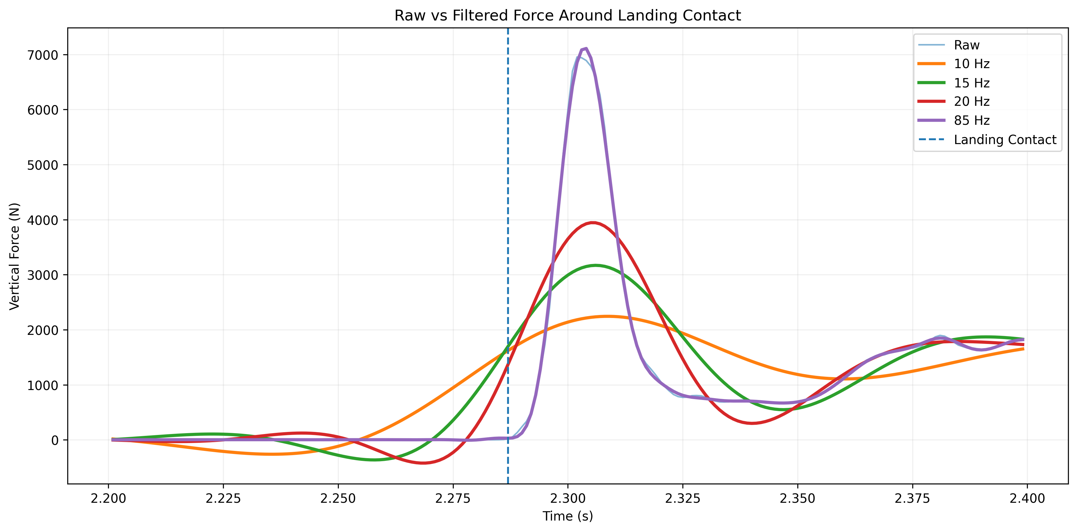

4. Weighing Phase, Body Weight, and COM Mechanics
Current development files use a 0.00-0.75 s pre-movement weighing interval because some exports provide less than one second of stable pre-jump data. The preferred acquisition procedure remains at least approximately one second of quiet standing when available. Body weight is calculated as the mean Fz during the selected sample period from the 15Hz signal, and body mass is BW/g using g = 9.81 m·s^-2.
Body weight, system mass, net force, center of mass mechanics, and external mechanical power are calculated using the following expressions. The 15Hz movement-mechanics signal is denoted Fz,15.
Body Weight
$BW=\frac{1}{t_{2}-t_{1}}\int_{t_{1}}^{t_{2}}{F_{z}}\left(t\right) dt$ (2)
Body Mass
$m=\frac{BW}{g}$ (3)
Net Vertical Force
$F_{net}\left(t\right)=F_{z,15}\left(t\right)-BW$ (4)
Center of Mass Acceleration
$a\left(t\right)=\frac{F_{net}\left(t\right)}{m}$ (5)
Center of Mass Velocity
$v\left(t\right)=\int_{t_{0}}^{t}{a}\left(τ\right) dτ$ (6)

Center of Mass Velocity
$d\left(t\right)=\int_{t_{0}}^{t}{v}\left(τ\right) dτ$ (7)
Center of Mass Displacement
$P\left(t\right)=F_{z,15}\left(t\right) v\left(t\right)$ (8)

5. CMJ Event and Phase Definitions

5.1 Movement Onset
CMJ onset is detected from the 15Hz force signal using a threshold based on the quiet standing body weight mean and baseline standard deviation. Force must remain outside the threshold band for at least 30 ms. The start is then shifted 30 ms backward to define movement onset.
Movement Onset Threshold
$F_{onset}=BW±5σ_{BW}$ (9)

5.2 Takeoff Detection
The original CMJ takeoff algorithm defined takeoff as the first point after the movement onset at which raw vertical force fell below 20N and remained below for at least 30ms. This design was adopted after false takeoffs were flagged. An example case saw raw force falling below 20 N for approximately 45 ms during the countermovement, even though true flight began much later. This exposed a limitation of the original fixed threshold approach, as a sustained low force period during the countermovement could satisfy the takeoff criterion despite the athlete remaining in contact with the force plates.
The revised CMJ takeoff detection procedure incorporates established force threshold methods while introducing application specific steps to address false takeoff detections observed during development. The use of a provisional 20N threshold and a flight noise derived threshold based on five standard deviations is supported by previous research (Smith et al., 2024). The selection of the longest unloaded interval, middle 50% flight noise window, and backward threshold search represent operational decisions developed specifically for this application.
The implemented sequence for takeoff detection is:
Table 2.
Step | CMJ takeoff procedure
1 | After movement onset, identify all contiguous raw force intervals below a provisional 20N threshold.
2 | Select the longest contiguous unloaded interval as the provisional flight phase.
3 | Use the middle 50% of that interval to estimate unloaded flight force mean and SD, avoiding takeoff and landing transitions.
4 | Calculate a trial specific takeoff threshold = mean flight force + 5 x SD flight force.
5 | Starting from the provisional flight interval, move backward to the beginning of the continuous raw force region below the trial specific threshold. That sample is final takeoff.
The provisional 20N value is therefore a flight finding aid, not the final CMJ takeoff threshold. The longest interval rule prevents shorter unloading periods from being mistaken as flight.

5.3 CMJ phases
After takeoff has been established from raw force, velocity-based phase detection is restricted to movement onset through takeoff, consistent with force-time approaches that define CMJ phases within the movement period (McMahon et al., 2018; Harry et al., 2020). In the present application, this bounded search also prevents post takeoff velocity values from being considered when identifying CMJ landmarks.
Table 3.
Phase | Operational definition
Unweighting | Movement onset -> minimum COM velocity
Braking | Minimum COM velocity -> first negative to positive COM velocity crossing
Propulsion | Zero-velocity crossing -> takeoff
Flight | Takeoff -> landing contact

Countermovement depth is the absolute COM displacement from movement onset to the zero-velocity transition. Because displacement is obtained by double integration, it is retained with an interpretation caveat and should be considered less reliable than force, impulse, or takeoff velocity.

6. Squat Jump Event and Phase Definitions
The SJ begins from a squat position held for 3 seconds and should contain no countermovement. Unlike the CMJ, which begins with an unweighting phase, the SJ is characterized by force production from a stationary position. Consequently, SJ movement onset is identified using a positive force threshold.
SJ onset is detected from the 15Hz filtered force signal when vertical force exceeds BW + 5 baseline SD for at least 30ms. The use of a threshold based on five standard deviations is supported by Pérez-Castilla et al. (2019), who demonstrated that SJ movement onset thresholds influence the reliability and magnitude of force-time variables. Their findings supported the use of a five SD threshold for identifying SJ initiation.
Unlike CMJ onset, SJ onset is assigned to the first sample of the sustained threshold crossing interval without shifting backward by 30ms. This is an application specific decision intended to identify the beginning of sustained propulsive force production. The 30ms persistence requirement reduces sensitivity to brief force fluctuations, while removing the backward adjustment avoids artificially extending the calculated propulsive phase.
SJ propulsion extends from movement onset to takeoff. Takeoff is identified as the first raw force sample below 20 N that begins a continuous period of at least 30ms below this threshold. Fixed force thresholds are commonly used to identify takeoff in force platform jump testing (Smith et al., 2024). The additional 30ms persistence requirement is retained as an operational safeguard against isolated low force samples.
This takeoff procedure has remained stable across the SJ trials evaluated during development. Therefore, the original SJ takeoff algorithm was retained rather than adopting the CMJ specific flight interval detection procedure.

7. Landing Contact and Landing Metrics

7.1 Landing contact
Landing contact is identified using raw vertical ground reaction force following takeoff. An initial fixed threshold of 20N is used to establish a provisional landing event. However, this provisional event is not reported as the final landing contact. Instead, a trial specific threshold is calculated using force measurements obtained during flight. A 100ms window extending from 150ms to 50ms before provisional landing contact, is selected to characterize the force signal while the athlete is not on the plates. The mean and standard deviation of vertical force within this window are then used to calculate the final landing contact threshold.

Landing Contact Threshold
$F_{contact}=μ_{flight}+5σ_{flight}$ (10)
Where $μ_{flight}$ represents the mean vertical force during the selected flight window and $σ_{flight}$ represents the standard deviation.
Final landing contact is identified as the first raw force sample exceeding this threshold following the flight noise window. This approach accounts for trial specific variation in unloaded force platform measurements rather than relying exclusively on an arbitrary fixed threshold. The methodology follows Harry et al. (2024), who recommended identifying landing contact using a threshold derived from the mean unloaded force plus five standard deviations.

7.2 Landing-impact filtering
Landing impact metrics are calculated from a separate 85Hz fourth-order zero-phase Butterworth signal. Campbell et al. (2020) found that a minimum cutoff of 85Hz was optimal for preserving peak ground reaction force in artistic gymnastics landing tasks. A sensitivity analysis for CMJ and SJ landings was performed to determine if 85hz could be a useful filtering cutoff for these tasks as well.
Table 4.
Landing signal | Peak landing force | Peak 20-ms loading rate
15 Hz | 3,170 N | 73,280 N/s
25 Hz | 4,594 N | 180,714 N/s
50 Hz | 6,533 N | 310,258 N/s
75 Hz | 7,066 N | 305,949 N/s
85 Hz | 7,110 N | 303,585 N/s
100 Hz | 7,101 N | 302,717 N/s
150 Hz | 7,008 N | 307,842 N/s
200 Hz | 6,975 N | 311,091 N/s
Raw | 6,955 N | 312,150 N/s

On a development trial, the 85Hz peak landing force was approximately 2.2% above raw and the 20ms loading rate approximately 2.7% below raw, whereas the 15Hz signal significantly dampened both these metrics.

7.3 Landing analysis window
Peak landing force and peak loading rate are searched within the first 300 ms after detected landing contact. This 300ms window is an application operational choice for Version 1 as recommendations were not found in literature.

8. Primary Metrics
Table 5.
Metric | Calculation / region
Jump height | h = v_{TO}² / (2g)
Takeoff velocity | Integrated COM velocity, v(t), at takeoff
Peak force | Maximum F_{z,15} from movement onset to takeoff
Peak propulsive power | Maximum F_{z,15}(t) v(t) during propulsion
Mean propulsive power | Mean F_{z,15}(t) v(t) during propulsion
Braking impulse (CMJ) | Integral of F_{net}(t) over the braking phase
Propulsive impulse | Integral of F_{net}(t) over the propulsive phase
Phase durations | Difference between detected event times
Countermovement depth (CMJ) | Absolute COM displacement from onset to zero-velocity transition
Peak landing force | Maximum F_{z,85} within the first 300ms after landing contact
Peak landing loading rate | Maximum 20ms moving force-time slope of F_{z,85} within the first 300ms after landing contact

8.1 Core outcome equations
Jump height is calculated from takeoff velocity using the impulse-momentum approach, while phase impulse is the time integral of net vertical force over the defined phase.
Jump Height Impulse-Momentum
$h=\frac{v_{TO}^{2}}{2g}$ (11)
Phase Impulse
$J_{phase}=\int_{t_{1}}^{t_{2}}{F_{net}}\left(t\right) dt$ (12)

9. Rate of Force Development and Loading Rate
Rate of force development (RFD) is retained as a secondary force-time metric rather than a main outcome. RFD is the slope of the force-time curve and therefore depends on both the force signal and the time interval over which the slope is calculated. Foundational work has quantified isometric RFD across multiple early contraction intervals, while later reviews emphasize that RFD is affected by physiological factors and by methodological choices including sampling frequency, filtering, onset detection, contraction mode, and calculation procedure (Aagaard et al., 2002; Maffiuletti et al., 2016; Rodríguez-Rosell et al., 2018).
Rate of Force Development
$RFD_{w}\left(t\right)=\frac{F_{z}\left(t+w\right)-F_{z}\left(t\right)}{w}$ (13)
For Version 1, peak braking and propulsive RFD are calculated with a 20ms moving window from the 15Hz signal. The complete window must remain within the relevant biomechanical phase, and the sign of the force-time slope is preserved. Haff et al. (2015) directly compared peak RFD sampling windows of 2, 5, 10, 20, 30, and 50ms during isometric midthigh clean pulls; the 20ms method showed the best absolute reliability among those peak window approaches. That evidence supports the calculation window choice, but it does not establish the reliability of dynamic CMJ RFD itself.
Max Phase Rate of Force Development
$RFD_{max,phase}=\max_{t∈phase}RFD_{w}\left(t\right), w=0.020 s$ (14)
Landing uses the term peak loading rate rather than peak landing RFD because the metric describes rapid external force loading after ground contact rather than voluntary neuromuscular force development. The same 20ms moving window concept is applied to the 85Hz landing impact signal. This terminology also avoids implying that landing loading rate and voluntary RFD are physiologically interchangeable.
Peak Landing Loading Rate
$LoadingRate_{20ms}=max\left(\frac{F_{z,85}\left(t+0.020\right)-F_{z,85}\left(t\right)}{0.020}\right)$ (15)
RFD and loading rate values are explicitly treated as processing sensitive. Maffiuletti et al. (2016) note that RFD is difficult to assess validly and reliably and that reliability is generally poorer during the earliest contraction phase. Rodríguez-Rosell et al. (2018) similarly emphasizes that RFD assessment is influenced by numerous methodological factors. Within the present development landing, changing the moving window produced approximately 638 kN/s at 10 ms, 304 kN/s at 20 ms, 43 kN/s at 30 ms, and 23 kN/s at 50 ms. Accordingly, these metrics should not be compared across systems, studies, or sessions without matching signal processing, event definitions, and window duration.

9.1 Scope of the RFD literature
Much of the foundational RFD literature evaluates rapid isometric contractions rather than dynamic jumping. In this project, those studies are used to support the mathematical definition of RFD, the importance of the calculation window, and the known sensitivity of RFD to processing choices. CMJ specific literature is used separately to define the biomechanical phases within which braking and propulsive RFD are searched. This distinction prevents isometric reliability findings from being generalized directly to dynamic jump RFD.

10. Processing Pipeline
1. Import ForceDecks raw CSV and retain Time, Left, and Right force columns.
2. Sum Left + Right to total vertical Fz and create relative time.
3. Estimate sampling frequency from timestamps.
4. Create 15Hz movement-mechanics and 85Hz landing impact force signals.
5. Estimate BW, baseline SD, and system mass from the pre-movement weighing interval.
6. Calculate net force, acceleration, COM velocity, displacement, and power.
7. Detect test specific movement onset.
8. For CMJ, identify the provisional longest unloaded interval, derive the flight-noise threshold, and detect final takeoff; for SJ, use sustained raw Fz < 20 N.
9. Detect CMJ velocity landmarks only within movement onset -> takeoff.
10. Calculate force, power, impulse, timing, jump height, depth, and phase-specific 20ms RFD metrics.
11. Detect landing contact from raw flight-noise threshold.
12. Calculate peak landing force and 20ms peak loading rate from the 85Hz signal within 300ms of contact.
13. Plot annotated phases/events and expose raw/filtered signals for visual inspection.
14. Export results with processing settings.

11. Interpretation and Reporting Notes
- Do not compare jump height values across systems or studies without checking the calculation method.
- Do not compare RFD or loading rate values without matching filtering, sampling frequency, event definitions, and moving window duration.
- Treat RFD/loading rate as more processing sensitive than force, impulse, takeoff velocity, and jump height.
- Raw force is deliberately retained for contact event detection because low-pass filtering can smear abrupt takeoff and landing transitions.
- The 15Hz and 85Hz cutoffs are Version 1 task specific choices supported by literature and sensitivity testing, not universal recommendations.
- Countermovement depth is double integration dependent and should be interpreted with more caution than directly force derived variables.
- Phase boundaries and event markers are marked on graph so users can visually inspect analysis.
- Processing settings are exported alongside metrics to support user reproducibility.

12. Literature Traceability of Core Definitions
Table 6.
Definition / decision | Application use | Supporting literature
RFD physiological basis | RFD is interpreted as rapid force production whose determinants vary across the early contraction period. | Aagaard et al. (2002); Andersen & Aagaard (2006); Maffiuletti et al. (2016); Rodríguez-Rosell et al. (2018) ^{1,2,9,15}
RFD calculation window | 20ms moving-window peak slope; full window must remain inside the biomechanical phase. | Haff et al. (2015); Maffiuletti et al. (2016) ^{6,9}
RFD methodological caution | Filtering, sampling, onset/event definition, contraction mode, and calculation method are treated as material sources of variation. | Maffiuletti et al. (2016); Rodríguez-Rosell et al. (2018) ^{9,15}
CMJ phase identification | GRF and COM-velocity features define unweighting, braking, propulsion, and takeoff-bounded phase analysis. | Harry et al. (2020); McMahon et al. (2018); Sahrom et al. (2020) ^{7,13,16}
COM mechanics | Body weight removal, acceleration, numerical integration to velocity/displacement, and force × velocity power. | McMahon et al. (2017); Thomas et al. (2022) ^{10,20}
CMJ reporting framework | Force, impulse, velocity, power, timing, phase, and strategy variables are interpreted within defined regions. | Anicic et al. (2023); McMahon et al. (2022) ^{3,12}
Jump height | Primary value is calculated from takeoff velocity using v²/(2g), with the equation explicitly reported. | Eythorsdottir et al. (2024); Xu et al. (2023) ^{5,21}
SJ onset / threshold sensitivity | Static-start jump onset and threshold selection are treated as processing choices that can affect outcomes. | Pérez-Castilla et al. (2019) ¹⁴
Landing contact | Raw-force landing contact uses a trial-specific flight-noise threshold rather than the filtered impact signal. | Harry et al. (2024) ¹⁴
Landing impact filtering | Separate high-cutoff signal is used for peak landing force and loading rate. | Campbell et al. (2020) ⁴

13. Numbered Literature References
1. Aagaard, P., Simonsen, E. B., Andersen, J. L., Magnusson, P., & Dyhre-Poulsen, P. (2002). Increased rate of force development and neural drive of human skeletal muscle following resistance training. Journal of Applied Physiology, 93(4), 1318–1326. https://doi.org/10.1152/japplphysiol.00283.2002
2. Andersen, L. L., & Aagaard, P. (2006). Influence of maximal muscle strength and intrinsic muscle contractile properties on contractile rate of force development. European Journal of Applied Physiology, 96(1), 46–52. https://doi.org/10.1007/s00421-005-0070-z
3. Anicic, Z., Janicijevic, D., Knezevic, O. M., Garcia-Ramos, A., Petrovic, M. R., Cabarkapa, D., & Mirkov, D. M. (2023). Assessment of countermovement jump: What should we report? Life, 13(1), 190. https://doi.org/10.3390/life13010190
4. Campbell, R. A., Bradshaw, E. J., Ball, N., Hunter, A., & Spratford, W. (2020). Effects of digital filtering on peak acceleration and force measurements for artistic gymnastics skills. Journal of Sports Sciences, 38(16), 1859–1868. https://doi.org/10.1080/02640414.2020.1757374
5. Eythorsdottir, I., Gløersen, Ø., Rice, H., Werkhausen, A., Ettema, G., Mentzoni, F., Solberg, P., Lindberg, K., & Paulsen, G. (2024). The battle of the equations: A systematic review of jump height calculations using force platforms. Sports Medicine, 54(11), 2771–2791. https://doi.org/10.1007/s40279-024-02098-x
6. Haff, G. G., Ruben, R. P., Lider, J., Twine, C., & Cormie, P. (2015). A comparison of methods for determining the rate of force development during isometric midthigh clean pulls. Journal of Strength and Conditioning Research, 29(2), 386–395. https://doi.org/10.1519/JSC.0000000000000705
7. Harry, J. R., Barker, L. A., & Paquette, M. R. (2020). A joint power approach to define countermovement jump phases using force platforms. Medicine & Science in Sports & Exercise, 52(4), 993–1000. https://doi.org/10.1249/MSS.0000000000002197
8. Harry, J. R., Simms, A., & Hite, M. (2024). Establishing phase definitions for jump and drop landings and an exploratory assessment of performance-related metrics to monitor during testing. Journal of Strength and Conditioning Research, 38(2), e62–e71. https://doi.org/10.1519/JSC.0000000000004700
9. Maffiuletti, N. A., Aagaard, P., Blazevich, A. J., Folland, J., Tillin, N., & Duchateau, J. (2016). Rate of force development: Physiological and methodological considerations. European Journal of Applied Physiology, 116(6), 1091–1116. https://doi.org/10.1007/s00421-016-3346-6
10. McMahon, J. J., Jones, P. A., Dos’Santos, T., & Comfort, P. (2017). Influence of dynamic strength index on countermovement jump force-, power-, velocity-, and displacement-time curves. Sports, 5(4), 72. https://doi.org/10.3390/sports5040072
11. McMahon, J. J., Rej, S. J. E., & Comfort, P. (2017). Sex differences in countermovement jump phase characteristics. Sports, 5(1), 8. https://doi.org/10.3390/sports5010008
12. McMahon, J. J., Ripley, N. J., & Comfort, P. (2022). Force plate-derived countermovement jump normative data and benchmarks for professional rugby league players. Sensors, 22(22), 8669. https://doi.org/10.3390/s22228669
13. McMahon, J. J., Suchomel, T. J., Lake, J. P., & Comfort, P. (2018). Understanding the key phases of the countermovement jump force-time curve. Strength & Conditioning Journal, 40(4), 96–106. https://doi.org/10.1519/SSC.0000000000000375
14. Pérez-Castilla, A., Rojas, F. J., & García-Ramos, A. (2019). Assessment of unloaded and loaded squat jump performance with a force platform: Which jump starting threshold provides more reliable outcomes? Journal of Biomechanics, 92, 19–28. https://doi.org/10.1016/j.jbiomech.2019.05.022
15. Rodríguez-Rosell, D., Pareja-Blanco, F., Aagaard, P., & González-Badillo, J. J. (2018). Physiological and methodological aspects of rate of force development assessment in human skeletal muscle. Clinical Physiology and Functional Imaging, 38(5), 743–762. https://doi.org/10.1111/cpf.12495
16. Sahrom, S. B., Wilkie, J. C., Nosaka, K., & Blazevich, A. J. (2020). The use of yank-time signal as an alternative to identify kinematic events and define phases in human countermovement jumping. Royal Society Open Science, 7(8), 192093. https://doi.org/10.1098/rsos.192093
17. Smith, J. C., Lamont, H. S., & Barefoot, M. (2024). Comparison of different take-off thresholds when assessing vertical jump performance. International Journal of Exercise Science, 17(1), 660–669. ⁠https://doi.org/10.70252/QBUA4521
18. Suchomel, T. J., McKeever, S. M., McMahon, J. J., & Comfort, P. (2020). The effect of training with weightlifting catching or pulling derivatives on squat jump and countermovement jump force-time adaptations. Journal of Functional Morphology and Kinesiology, 5(2), 28. https://doi.org/10.3390/jfmk5020028
19. Suchomel, T. J., McKeever, S. M., Sijuwade, O., & Carpenter, L. (2023). Propulsion phase characteristics of loaded jump variations in resistance-trained women. Sports, 11(2), 44. https://doi.org/10.3390/sports11020044
20. Thomas, C., Jones, P. A., & Dos’Santos, T. (2022). Countermovement jump force-time curve analysis between strength-matched male and female soccer players. International Journal of Environmental Research and Public Health, 19(6), 3352. https://doi.org/10.3390/ijerph19063352
21. Xu, J., Turner, A., Comfort, P., Harry, J. R., McMahon, J. J., Chavda, S., & Bishop, C. (2023). A systematic review of the different calculation methods for measuring jump height during the countermovement and drop jump tests. Sports Medicine, 53(5), 1055–1072. https://doi.org/10.1007/s40279-023-01828-x

